**EXPERIMENT NO – 8**

**AIM:** Implementation of Foot Printing Lab.

**THEORY**:

Footprinting (also known as reconnaissance) is the technique used for gathering information about computer systems and the entities they belong to. To get this information, a hacker might use various tools and technologies. This information is very useful to a hacker who is trying to crack a whole system.

When used in the computer security lexicon, "Footprinting" generally refers to one of the pre-attack phases; tasks performed before doing the actual attack. Some of the tools used for Footprinting are Sam Spade, nslookup, traceroute, Nmap and neotrace.

**USES OF FOOTPRINTING**:

It allows a hacker to gain information about the target system or network. This information can be used to carry out attacks on the system. That is the reason by which it may be named a Pre-Attack, since all the information is reviewed to get a complete and successful resolution of the attack. Footprinting is also used by ethical hackers and penetration testers to find security flaws and vulnerabilities within their own company's network before a malicious hacker does.

**Practical**:

**OUTPUT:**

**WEB TOOL: WHOIS LOOKUP**

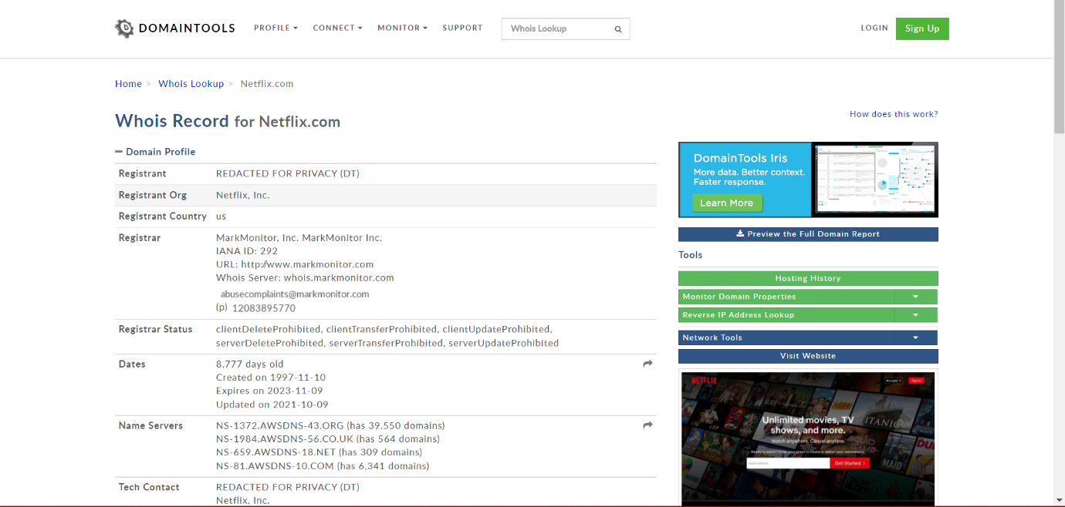

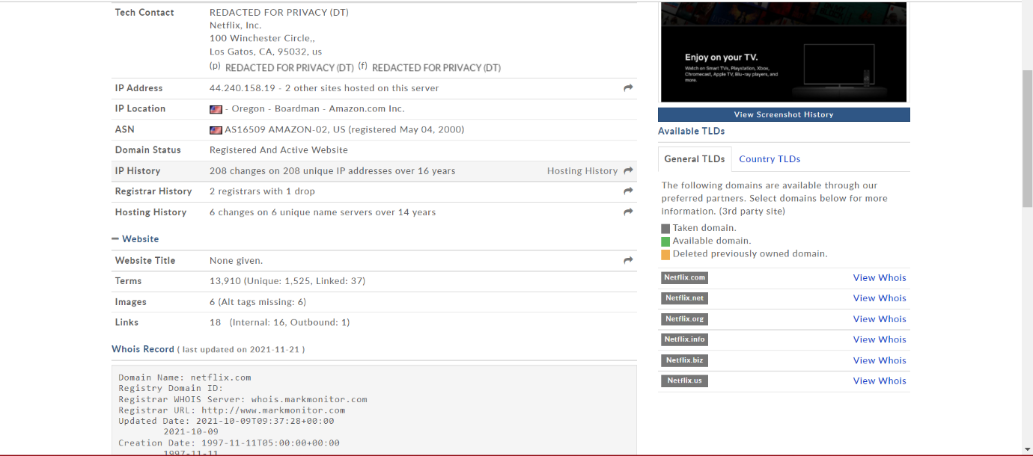

Whois Record of Netflix.com:

Domain Name: netflix.com  
Registry Domain ID:   
Registrar WHOIS Server: whois.markmonitor.com  
Registrar URL: http://www.markmonitor.com  
Updated Date: 2021-10-09T09:37:28+00:00  
        2021-10-09  
Creation Date: 1997-11-11T05:00:00+00:00  
        1997-11-11  
Registrar Registration Expiration Date: 2023-11-10T00:00:00+00:00  
        2023-11-10  
Registrar: MarkMonitor, Inc.  
        MarkMonitor Inc.  
Sponsoring Registrar IANA ID: 292  
Registrar Abuse Contact Email: [](https://reversewhois.domaintools.com/?email=86f127e68052cf1961e02764e9684f46)  
Registrar Abuse Contact Phone: 12083895770  
Status:   
        clientDeleteProhibited  
        clientTransferProhibited  
        clientUpdateProhibited  
        serverDeleteProhibited  
        serverTransferProhibited  
        serverUpdateProhibited  
Registry Registrant ID:   
Registrant Name: REDACTED FOR PRIVACY (DT)  
Registrant Organization: Netflix, Inc.  
Registrant Street: 100 Winchester Circle,  
Registrant City: Los Gatos  
Registrant State/Province: CA  
Registrant Postal Code: 95032  
Registrant Country: us  
Registrant Phone: 14085403700  
Registrant Phone Ext:   
Registrant Fax: 14085403737  
Registrant Fax Ext:   
Registrant Email: REDACTED FOR PRIVACY (DT)  
Registry Admin ID:   
Admin Name: REDACTED FOR PRIVACY (DT)  
Admin Organization: Netflix, Inc.  
Admin Street: 100 Winchester Circle,  
Admin City: Los Gatos  
Admin State/Province: CA  
Admin Postal Code: 95032  
Admin Country: us  
Admin Phone: REDACTED FOR PRIVACY (DT)  
Admin Phone Ext:   
Admin Fax: REDACTED FOR PRIVACY (DT)  
Admin Fax Ext:   
Admin Email: REDACTED FOR PRIVACY (DT)  
Registry Tech ID:   
Tech Name: REDACTED FOR PRIVACY (DT)  
Tech Organization: Netflix, Inc.  
Tech Street: 100 Winchester Circle,  
Tech City: Los Gatos  
Tech State/Province: CA  
Tech Postal Code: 95032  
Tech Country: us  
Tech Phone: REDACTED FOR PRIVACY (DT)  
Tech Phone Ext:   
Tech Fax: REDACTED FOR PRIVACY (DT)  
Tech Fax Ext:   
Tech Email: REDACTED FOR PRIVACY (DT)  
Registry Billing ID:   
Billing Name:   
Billing Organization:   
Billing Street:   
Billing City:   
Billing State/Province:   
Billing Postal Code:   
Billing Country:   
Billing Phone:   
Billing Phone Ext:   
Billing Fax:   
Billing Fax Ext:   
Billing Email:   
Nameservers:   
        ns-1372.awsdns-43.org  
        ns-1984.awsdns-56.co.uk  
        ns-659.awsdns-18.net  
        ns-81.awsdns-10.com  
Registry ID: 1404215_DOMAIN_COM-VRSN  
DNSSEC: unsigned

**WEB TOOL: NETCRAFT**

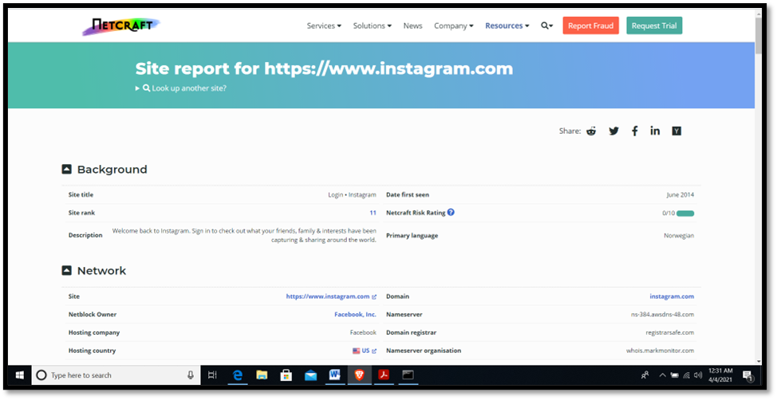

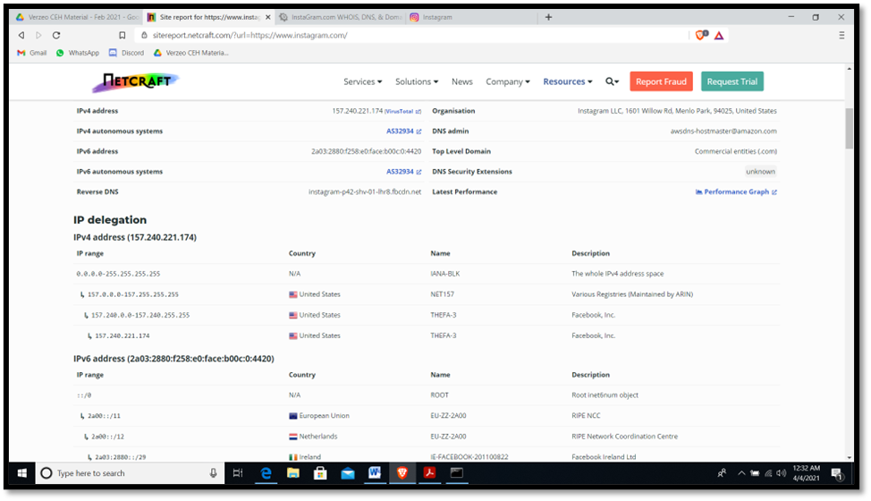

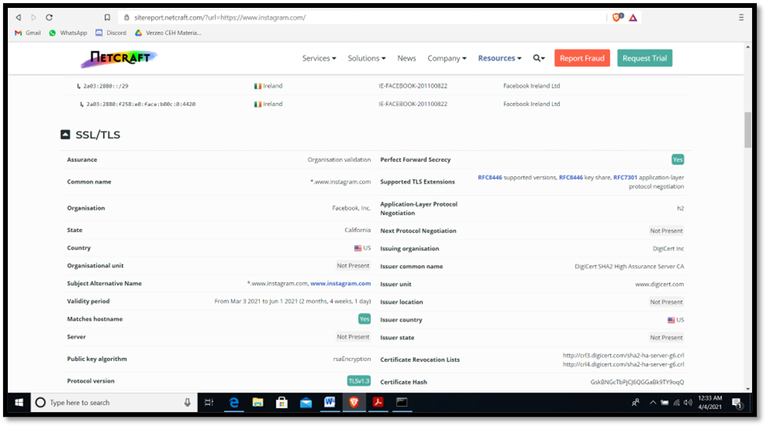

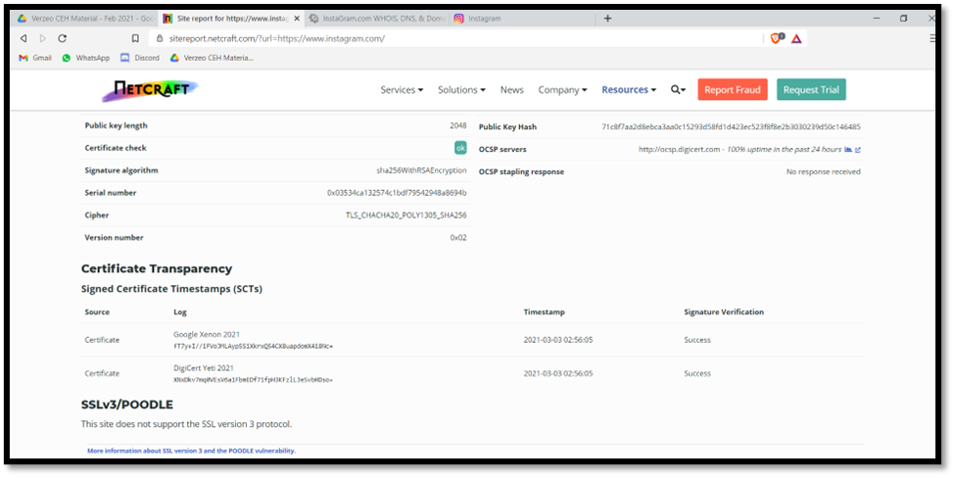

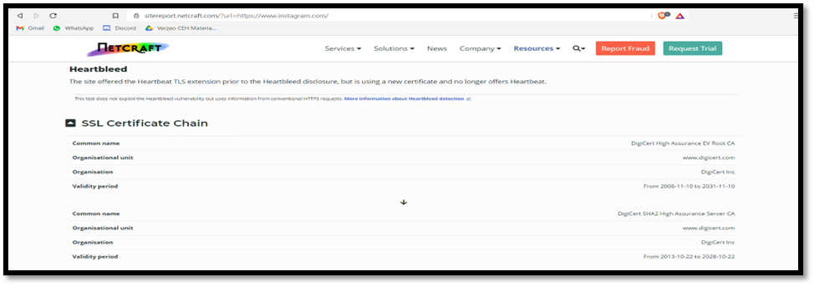

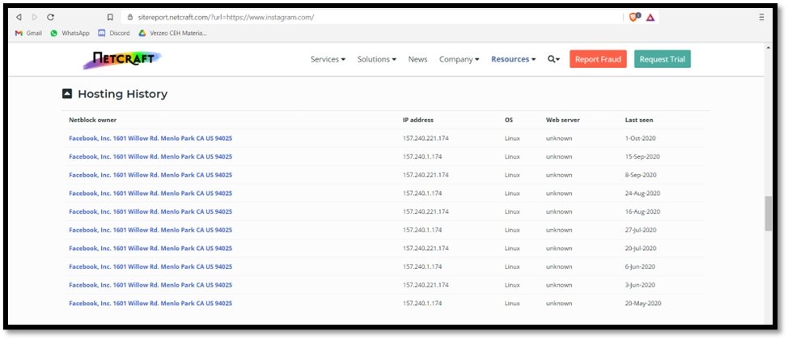

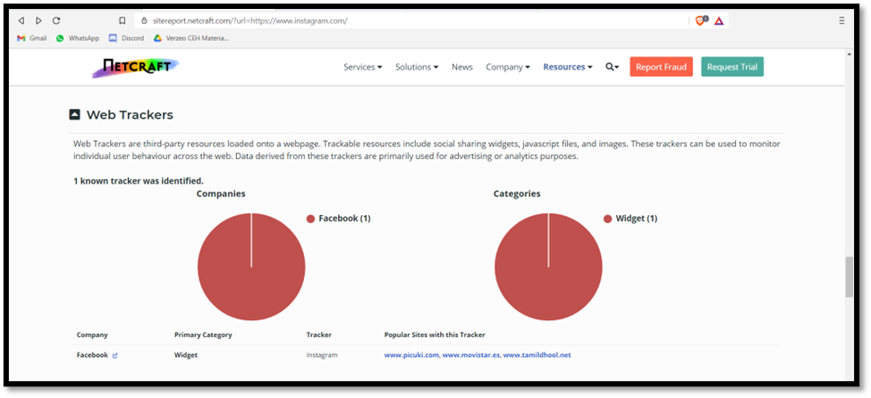

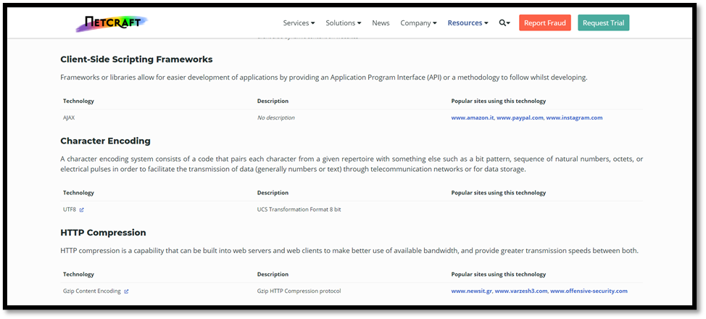

**WEB TOOL: DOMAIN DOSSIER**

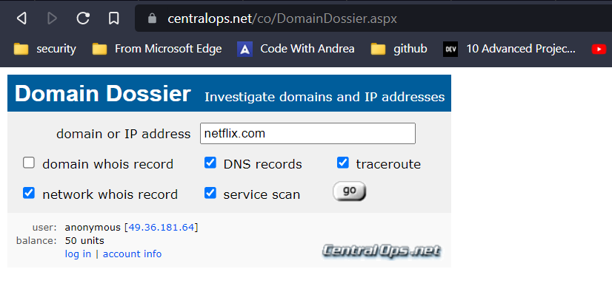

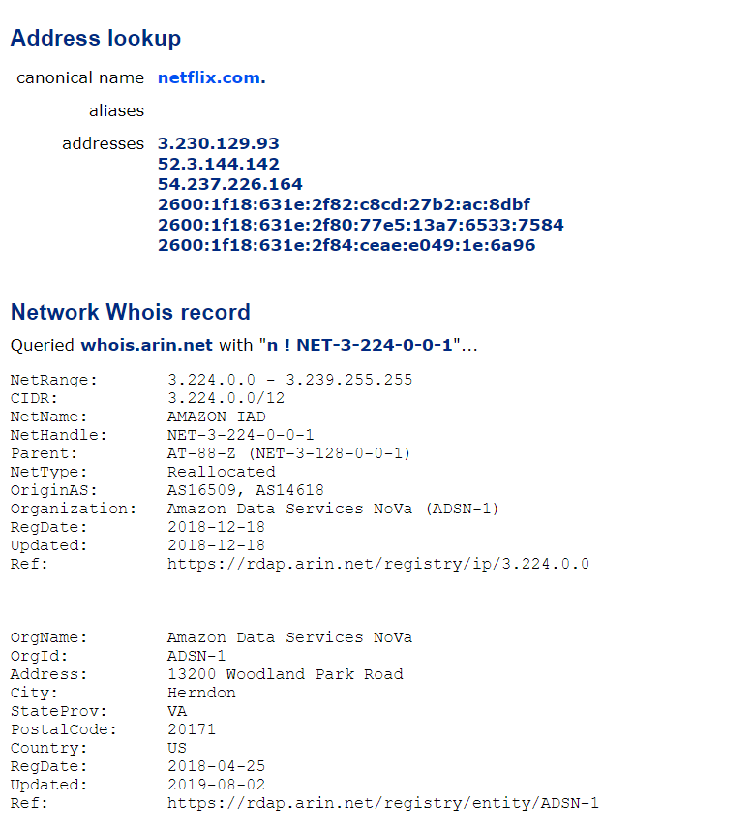

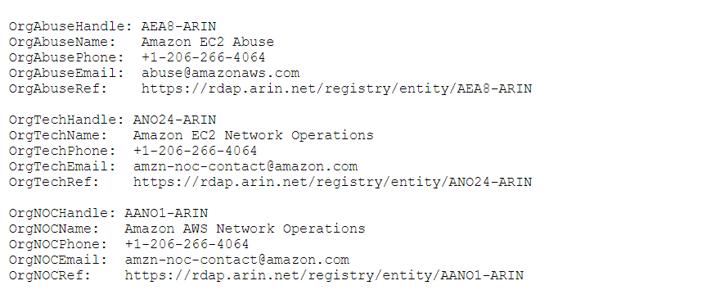

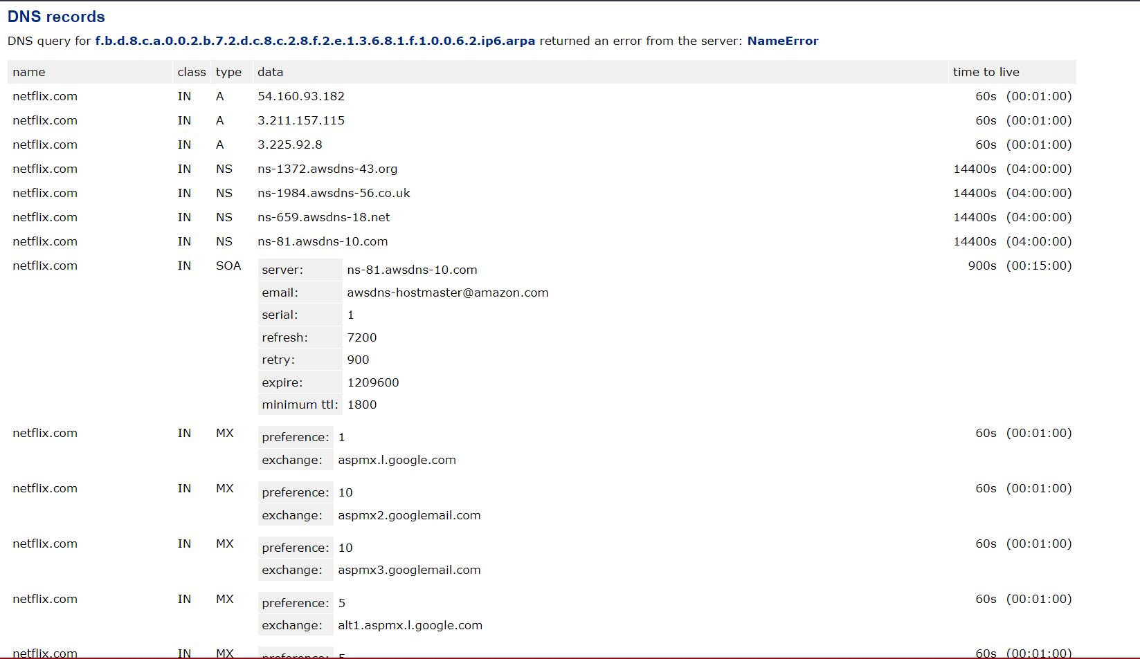

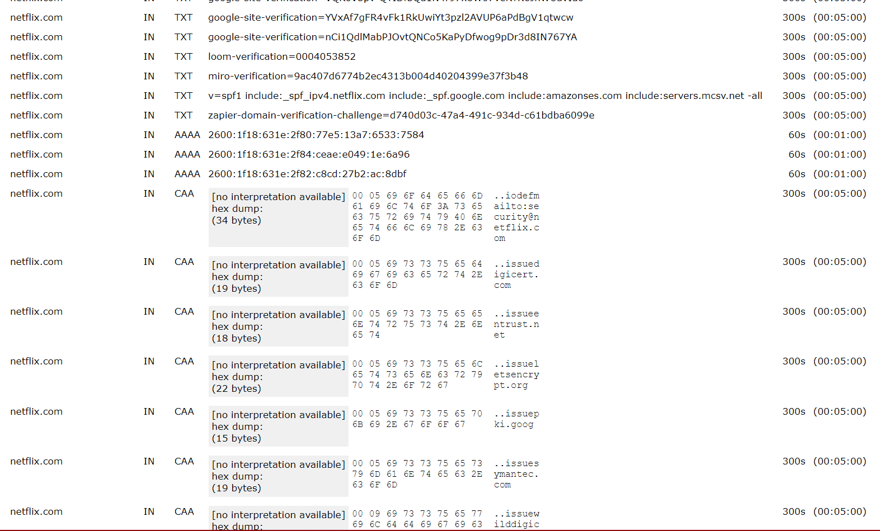

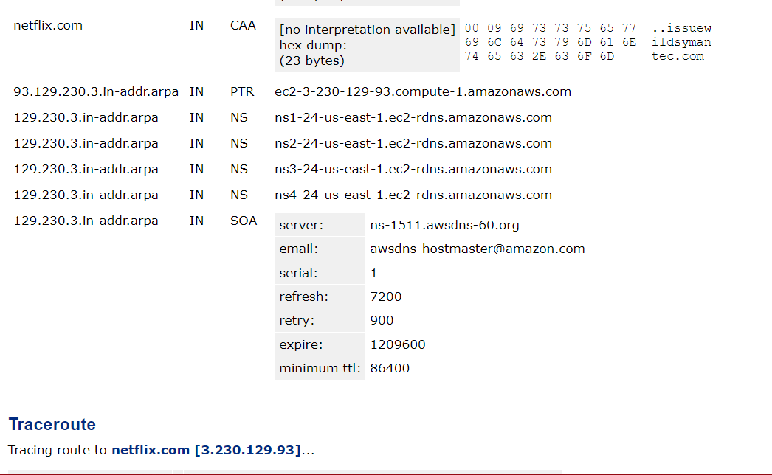

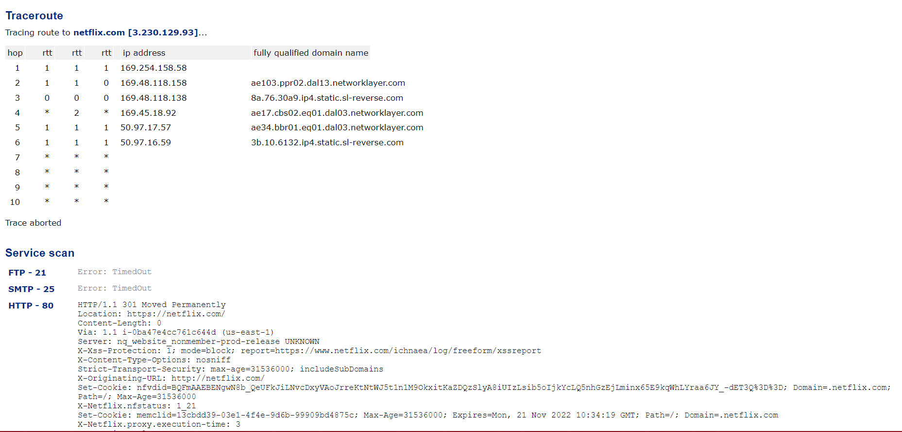

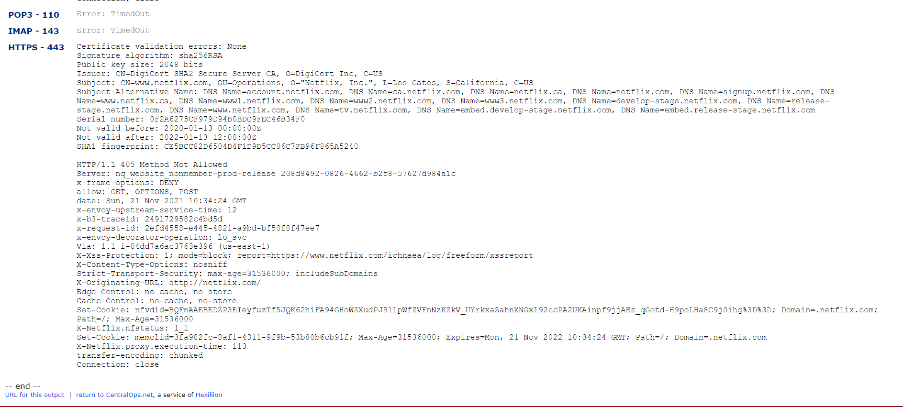

**DNS RECON**:

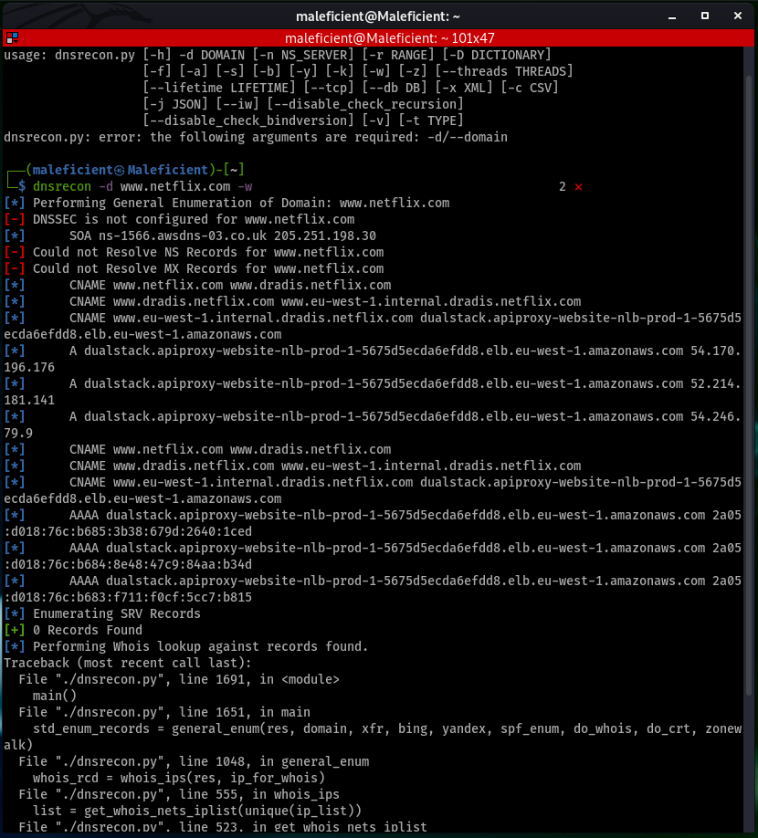

**DNS ENUM**:

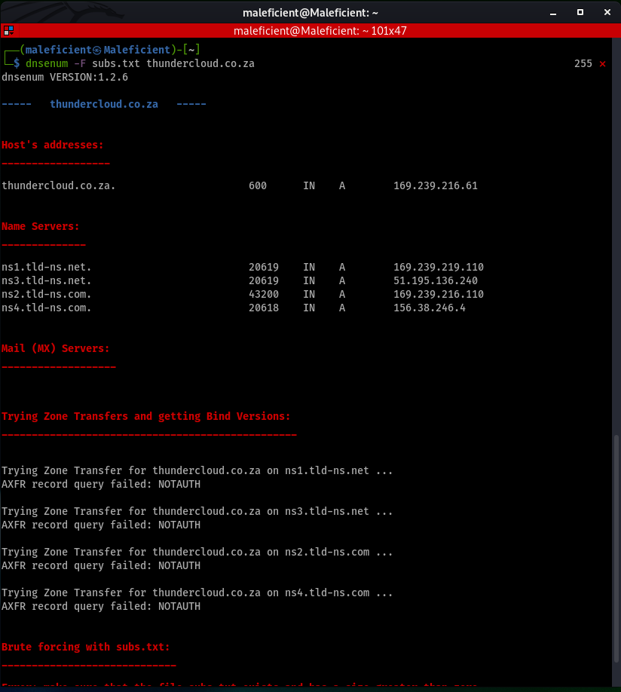

**WEB TOOL: DNS DUMPSTER**

